**Retrieve users based on their user ID**

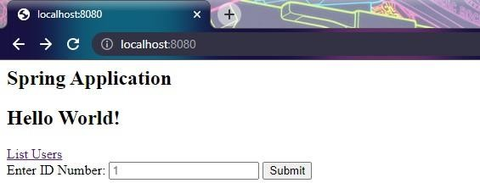

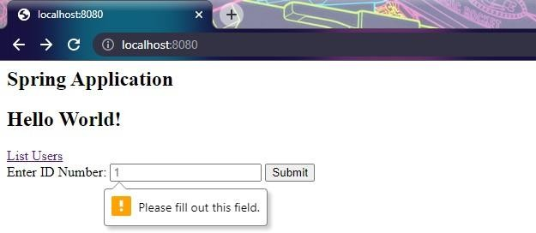



@l I oca1host:8080/search/%7BidS” x

# Search for User

ID Name Email Password l Manager managerHgrnad.coin manager

Update this User?



New Name.

aM ged

New Eiriail.

n age gm i om

New Passuwrd. gmeta

bum t

Return to Memi



# Update Successful

Updated User Credentials. 1 Manager [manager@quail.coin](mailto:manager@quail.coin) admin

Return to Menu



@l localhost:8080/search/9L7Bid%” x

*+*

C

te alhast

# Search for User

ID Name Eznail Password l Manager managerHgrnail.coin admin

Update This User?



New Name.

aM ged

New Exriail.

nage gm i om

New Passumd.

ad i

bum t

Return to Memi



Something went wrong!

# Our Engineers are on it

Go Home